**Directions Hunters Camp USFS Dispersed Camping Area**

40°09'26.9"N 121°17'23.9"W

40.1574714, -121.2899597

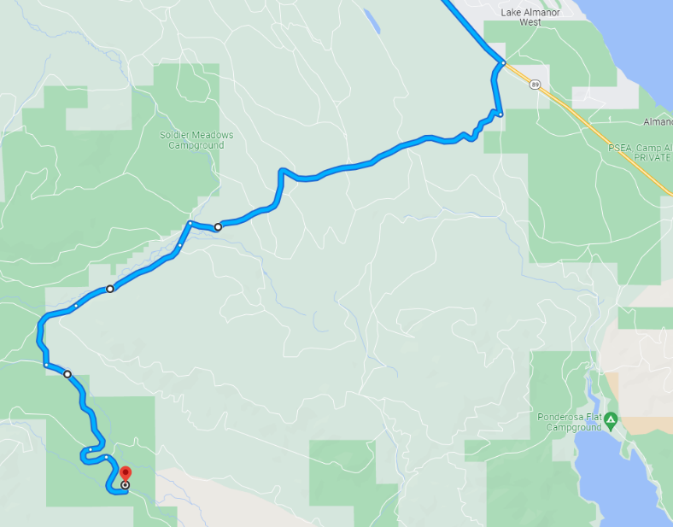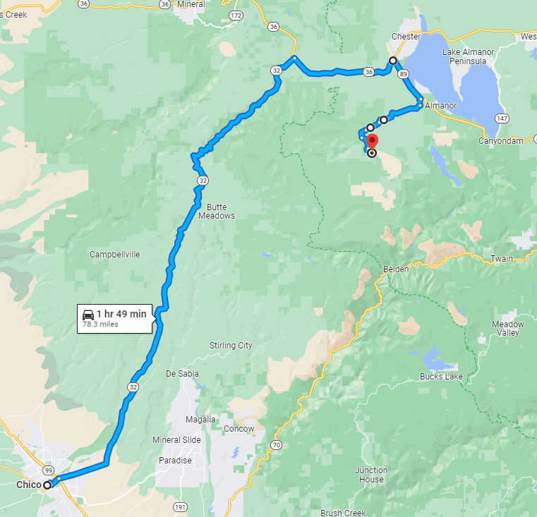

Please note that Google Maps may suggest routes for high clearance vehicles only or through impossible to navigate logging roads. We recommend using the directions shown below. Take 32 to 36 to 89, then take Humboldt Rd and Road 27N04 to the dispersed camping area.

**From Chico, CA**

* Head towards Chester Via Hwy 32 E for approximately 50 miles
* After ~50 miles on Hwy 32 E, turn right onto State Hwy 36 E towards Chester/Lake Almanor for 10 miles
* After 10 miles on Hwy 36 E, turn right onto Hwy 89 S for ~4 miles
* Turn right onto Humbug Humboldt Cross Rd
* After 0.6 miles take a slight right onto Humboldt Rd
* After 4.3 miles, take a left just past Soldier Creek onto Road 27N04 that runs parallel to Butt Creek on the south side of the creek
* Slight right after 0.3 mile
* Slight right after 1.4 miles
* Turn left after 1 mile
* Keep left after 1.4 miles
* Slight right after 0.5 mile
* Continue approximately 0.4 miles and look for dispersed camping area on your left. We will put a sign out on the road to help guide you to the dispersed camping area.